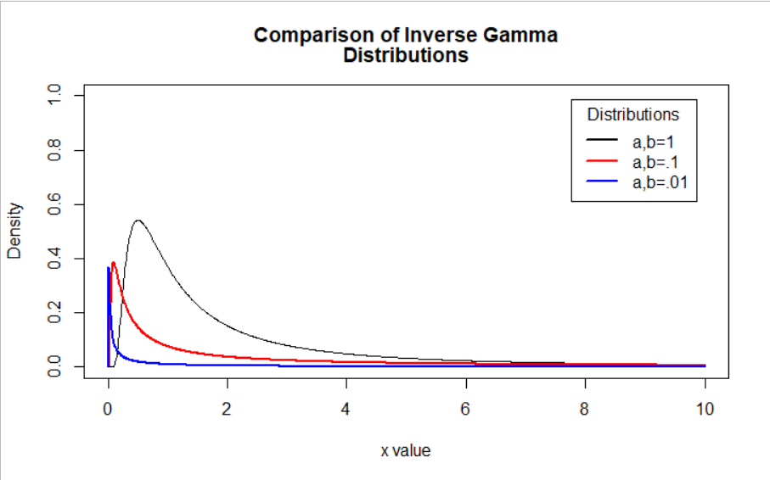

From [Gelman 2006 Paper](http://www.stat.columbia.edu/~gelman/research/published/taumain.pdf): Compared different “uninformative” priors including some inverse gamma (but also uniform, Cauchy):

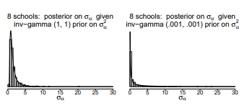

Smaller shape and scale parameters pulled the variance estimate towards 0. Which makes sense given the first plot, where we can see that as shape and rate get smaller, the peak of the distribution is closer to 0. So in a sense, the inverse gamma with smaller shape and scale could actually be more informative (despite having a shorter tail), but I think it would depend on the actual value of sigma.

So I do think this image is misleading (plus there is an error – shape and scale should stay the same)

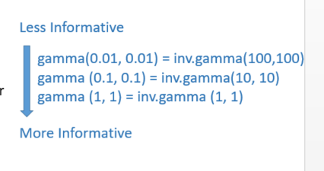

What might be more accurate would be

Variance pulled towards 0 🡪 stock-specific alphas pulled closer to eachother

$$τ_{α}\sim gamma\left(0.01, 0.01\right) = σ_{α}\sim inv.gamma(0.01, 0.01)$$

$$τ_{α}\sim gamma\left(0.1, 0.01\right) = σ_{α}\sim inv.gamma(0.1, 0.01)$$

$$τ_{α}\sim gamma\left(1, 1\right) = σ_{α}\sim inv.gamma(1, 1)$$

Variance allowed to be farther from 0 🡪 stock-specific alphas allowed to vary more from eachother